

Customer Retention

Submitted by:

Chitrak Satyarthi

**ACKNOWLEDGMENT**

I would like to express my special thanks of gratitude to my mentor as well as the company for giving me the golden opportunity to do this wonderful project on the topic **Customer Retention**, which also helped me in doing a lot of Research and I came to know about so many new things I am really thankful to them.

**INTRODUCTION**

* Business Problem Framing

You’ve heard it time and time again. It’s cheaper to get current customers to make a repeat purchase than it is to find new customers. It’s true for many businesses, especially in the crowded ecommerce arena where clicks and conversions always seem to be increasing in cost.

When was the last time you made an effort to re-engage customers to get them to come back? If you've yet to market to current customers after the sale, now is a good time to build a cohesive strategy for customer retention. Let's look at how to get started.

* Conceptual Background of the Domain Problem

Customer retention is the collection of activities a business uses to increase the number of repeat customers and to increase the profitability of each existing customer.

Customer retention strategies enable you to both provide and extract more value from your existing customer base. You want to ensure the customers you worked so hard to acquire stay with you, have a great customer experience, and continue to get value from your products.

In short, acquisition creates a foundation of customers while your retention strategy is how you build customer relationships and maximize revenue for each one. But how much time and resources should you devote to your retention program? The answer to that depends on your store.

* Review of Literature

Whether you should focus more on customer acquisition or retention is heavily influenced by where your store is in its lifecycle. A store that started yesterday is vastly different than one that’s been up and running for many years.

Take a look at the timeline below for general guidance on your store’s potential investment levels.

* Motivation for the Problem Undertaken

What you sell has a huge impact on which strategy you should focus on. A retailer selling high-end leather furniture is going to be categorically different than a store selling tea and coffee.

A store whose customers purchase high value items frequently will have the highest [customer lifetime value](https://www.shopify.com/blog/customer-lifetime-value) (CLV). These are the types of stores that have the most to gain from a solid retention strategy.

* Data Pre-processing Done

Usually the data was analysed on the basic knowledge, which were required, basically the data with the null values were removed. Rest of the data was analysed using histogram and other charts which were required for the EDA and were considered or removed biased on the analysis.

* Hardware and Software Requirements and Tools Used

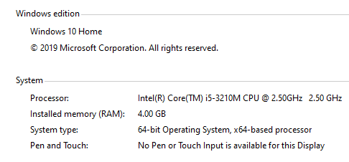

**CONCLUSION**

* Data suggests that while delight has its place, customers see fast, friendly, and consistent customer service as the gold standard. If you help customers avoid problems and get the most out of your products, you’ll be doing both of you a favor.
* Depending on your niche, product mix, and margins, sending a small gift to your best customers can be a great way to remind them to return while adding the element of surprise and delight, which can increase customer satisfaction. Giving an unexpected gift also plays to the law of [reciprocity](http://en.wikipedia.org/wiki/Reciprocity_(social_psychology)), which refers to our tendency to respond to a positive action with another positive action.